**Pir motion detection system using raspberry pi pico w**

**GROUP NAME:**

**1.S.SAI JANGAM REDDY (21781A04G9)**

**2.T.SIVA MALLIKARJUN REDDY (21781A04J5)**

**3.S.REDDY PURUSHOTHAM (21781A04J3)**

**4.S.AKASH REDDY (21781A04H8)**

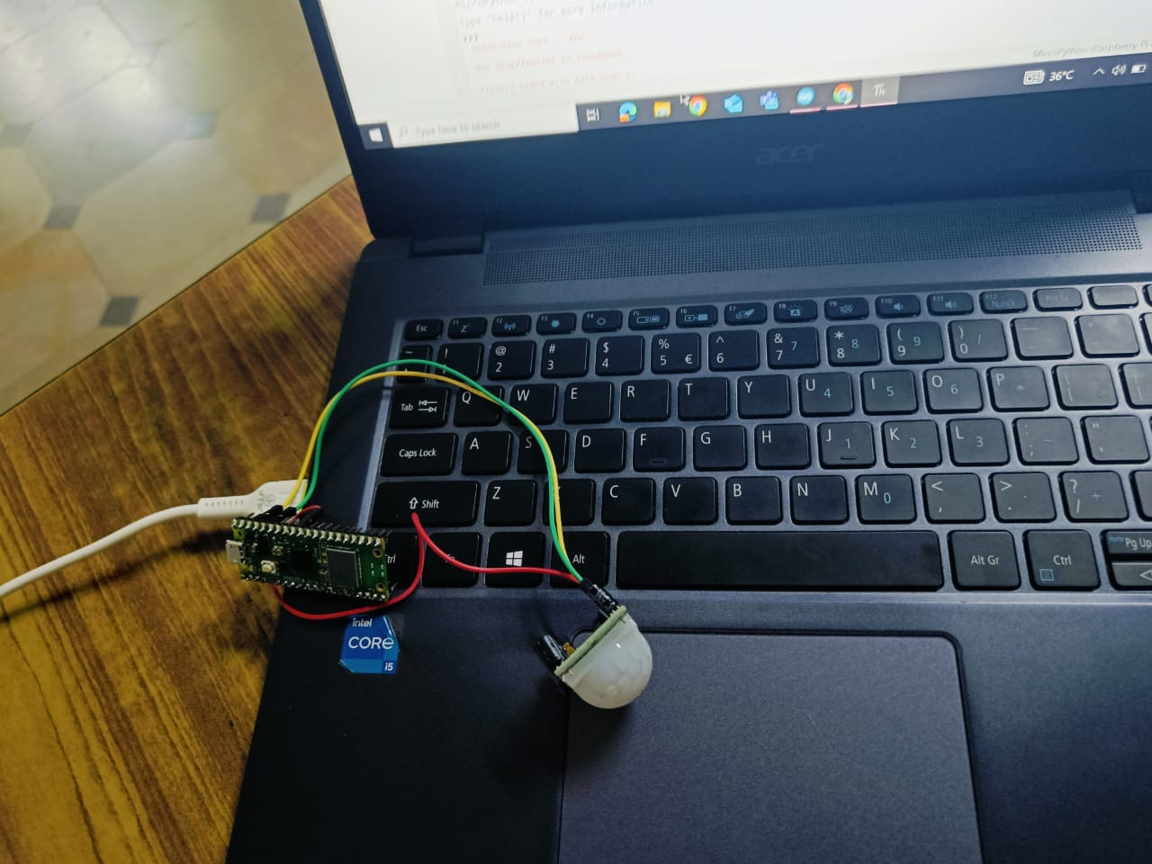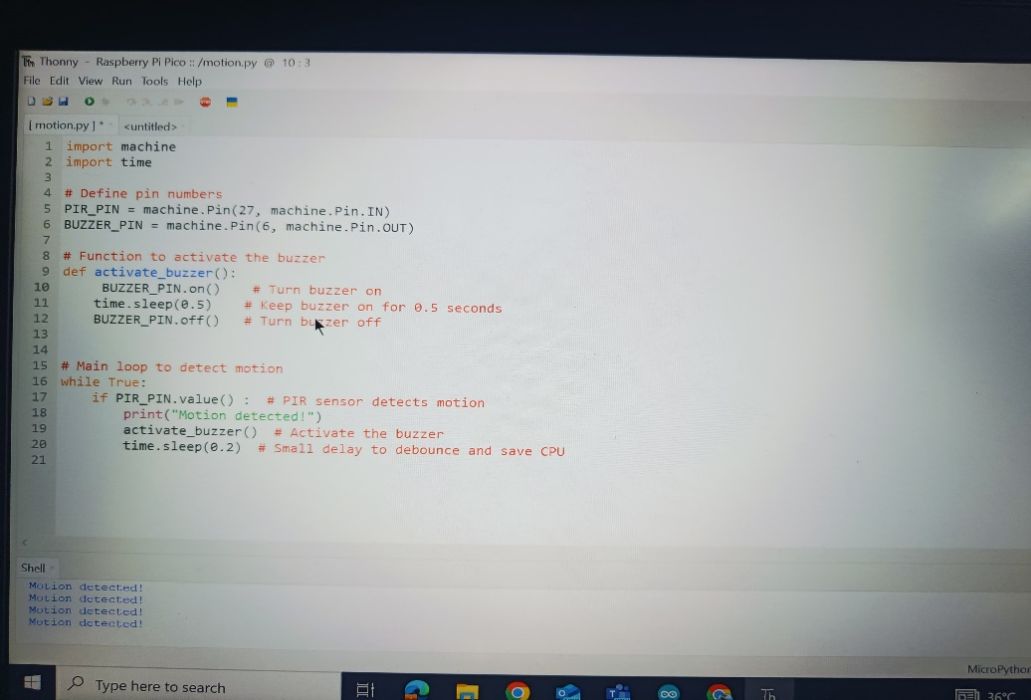**5.S.NARESH (21781A04G7)**